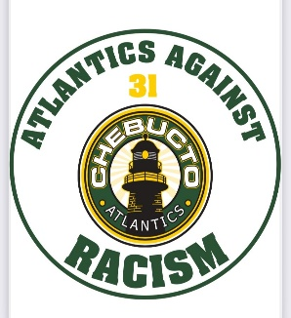
Message to all Hockey Families,

"The Chebucto Minor Hockey Association family stands with our hockey partners in denouncing recent allegations of racism and discrimination in the game. Chebucto wishes to make clear that racism and discrimination have no place in hockey or society. We stand with and support those who face racism and discrimination, and will show our continued support by introducing a Chebucto helmet decal against racism. We also encourage our membership to call out racism and discrimination whenever it occurs.”
CMHA Executive Board &
Dean Smith
HNS Diversity and Inclusion Chair

