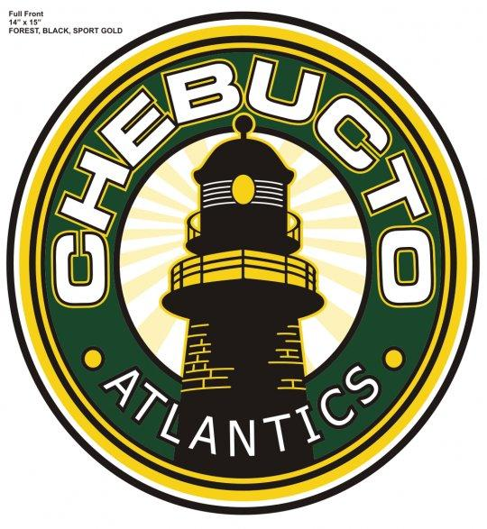

Chebucto Minor Hockey Association

Agenda AGM -2021-2022 Season

Location: Atlantic Room- Spryfield Lions Rink
Date: May 17th , 2022
Time: 7:00 pm

Business:

- President’s Remarks
- RIC- Chris Newel- Retention and Recruitment
- VP -Year end reports
- Questions/Comment from Membership

Adjournment

